***PLEASE RENAME MANUSCRIPT ACCORDING TO YOUR PAPER ID.***

**Please write your text in good English**

**(American or British usage is accepted, but not a mixture of these).**

PAGE 1

**Concise and Informative Article Title**

**(Limited to 8-16 Words, Relevant to the Subject, in Single Phrase, Correct Grammar & Proper Capitalization, Avoid Abbreviations)**

Name of Author1,*, Name of Author2, Name of Author3

1Full affiliation of first author, including country, 1Email:..... , ORCID iD (if possible):

2Full affiliation of first author, including country, 2Email:..... , ORCID iD (if possible):

3Full affiliation of first author, including country, 3Email:..... , ORCID iD (if possible):

*Corresponding Author: Name of Author, ( Email:....)

**Abstract:** (**Should contain an unstructured abstract of 300 words.**)

A single paragraph of about 200-300 words maximum. For research articles, abstracts should give a pertinent overview of the work.

* Place the question addressed in a broad context and highlight the purpose of the study.
* briefly describe the main methods or treatments applied;
* summarize the article's main findings;
* Indicate the main conclusions or interpretations.

The abstract should be an objective representation of the article and it must not contain results that are not presented and substantiated in the main text and should not exaggerate the main conclusions.

**Keywords:** Immediately after the abstract, provide **minimum of 5 keywords,** and avoiding general and plural terms and multiple concepts (avoid, for example, 'and', 'of'). Be sparing with abbreviations: only abbreviations firmly established in the field may be eligible. Keywords are used throughout the abstract in a natural way, without affecting readability.

PAGE 2

**“IMRaD” format refers to a paper that is structured by four main sections: Introduction, Methods, Results, and Discussion.**

**1. Introduction**

The introduction should identify key ideas of the research, why it is important; pose research question that needs to be answered and how the findings contribute to the discipline. (**Introduction should not contain sub-headings**)

**2. Literature review/Study site**

This section is very important for your article. Review the main articles related to the main theme of your work. Summarize a number of articles which you have considered related and important for your research.

***Subdivision - numbered sections***

Divide your article into clearly defined and numbered sections, should be numbered 2.1 (then 2.1.1, 2.1.2, ...), 2.2, etc.

**3. Materials and Methods/** **Methodology**

Select and describe the methodology you have summarized in the previous section. It can be the same as in a previous related work, a modified one you considered more appropriate or a mix of the methods you have analysed in the literature review section.

**4. Results and Discussion**

This part includes the results, tables, figures, formulae with references, data source references, evaluation of validity for calculations and discussion. This part may be divided in balanced sub-parts.

**5. Conclusion**

The main conclusions of the study may be presented in a short Conclusions section, which may stand alone or form a subsection of a Discussion or Results and Discussion section.

**6. Ethical Approval**

An ethical approval statement is required for any article that involves (**Human Participants**), including surveys, questionnaires, or any data from humans, whether it is collected online or in-person.

* All the studies involving humans or animals must obtain ethical approval from the institutional board before being carried out.
* Details of this approval must be provided when submitting an article; including the institution, review board name, and permit number(s)

*Ethics approval must be obtained before the research is conducted; retrospective approval can usually not be obtained and it may not be possible to publish the study.*

**If you did not need ethical approval for your study you will need a clear statement in the article that explains why your study did not require that you obtain ethical approval.**

**7. Data Availability (Demo Tutorial:** [**https://youtu.be/c76SI52bKYM**](https://youtu.be/c76SI52bKYM)**)**

Authors are encouraged to share the data underlying their study and include a Data Availability Statement in the manuscript.

***Underlying Data:-*** Data that underlie the results of the Study (Either RAW or SOURCE).

**RAW date:** Uncropped western blots, survey results, sequences, transcripts, spectra.

*Authors* ***must upload*** *the data to a data repository (Figshare.com)*

**SOURCE data:** Datasets used form other researchers, Demographic health survey

*Author* ***must provide information*** *about where they obtained this source data.*

***Extended Data:-*** Material equivalent to supplementary material.

(Examples: questionnaires, consent statements, statistical analysis calculation, supplementary figures)

*Authors* ***must upload*** *the data to a data repository (Figshare.com)*

**e.g. Data Availability Statement example in article.**

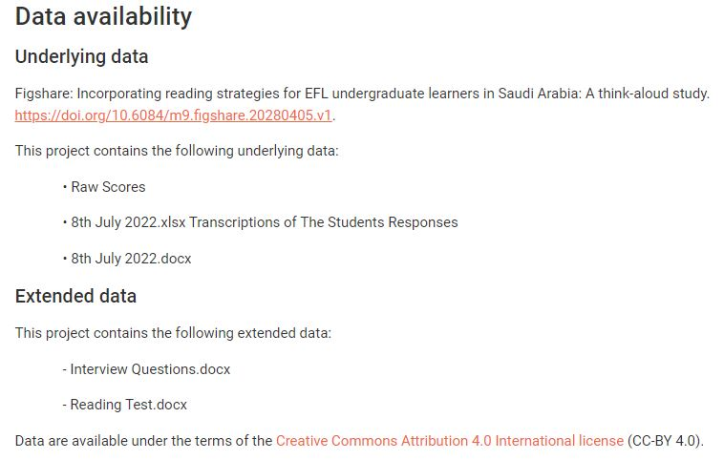

*Upload the Data in [https://figshare.com/] and get the DOI.*

**All articles must include a Data Availability statement, even where there is no data associated with the article.**

**No associated or additional data**

*For articles which have no associated data, the statement should read:*

*“No data are associated with this article.”*

*For articles where all associated data are presented in the article itself, please include the statement:*

*“All data underlying the results are available as part of the article and no additional source data are required.”*

**8. Grant information/Funding:**

Enter the funding body name, grant number (optional) separate multiple numbers with commas

**9. References (Citation in text)**

**Please ensure that every reference cited in the text is also present in the reference list (and vice versa).** References should be prepared according to the Publication Manual of the APA (6th, 7th edition). Your citations and references should be in static text (not as linked fields. Linked fields (non static text) will be lost during formatting. ”**All un-cited references will be automatically removed.**

***The references should not contain footnotes. References are listed fully in alphabetical order according to the last name of the first author and not numbered. For your information, our citation style is:***

**Reference to a journal publication:**

Van der Geer J, Hanraads JAJ, Lupton RA. The art of writing a scientific article. J Sci Commun 2010;163:51–9.

**Reference to a book:**

Strunk Jr W, White EB. The elements of style. 4th ed. New York: Longman; 2000.

**Reference to a chapter in an edited book:**

Mettam GR, Adams LB. How to prepare an electronic version of your article. In: Jones BS, Smith RZ, editors. Introduction to the electronic age, New York: E-Publishing Inc; 2009, p. 281–304.

**Reference to a website:**

Cancer Research UK. Cancer statistics reports for the UK,

http://www.cancerresearchuk.org/aboutcancer/statistics/cancerstatsreport/; 2003 [accessed 13 March 2003].

**NOTE: Figures and tables should have legends. Ensure all figure and table citations in the text match the files provided**

**Advice on Tables:**

**Please submit tables as editable text and not as images.** Tables can be placed either next to the relevant text in the article, or on separate page(s) at the end. Every table must have a descriptive title and, if numerical measurements are given, the units should be included in the column heading. Vertical rules should not be used (see Table 1). Tables should be cited consecutively in the text.

**Table 1**: Temperature and wildlife count in the three areas covered by the study.

|  |  |  |  |  |  |
| --- | --- | --- | --- | --- | --- |
| Location | T [°C] | Turtles | Sharks | Octopuses | Starfish |
| Blue Lagoon | 21.2 | 5 | 3 | 4 | 543 |
| Regent’s Canal | 5.2 | 8 | 0 | 24 | 312 |
| Shark Bay | 12.8 | 4 | 7 | 9 | 122 |

**Advice on Figures:**

Each figure or table should be mentioned in the text with its number either immediately before or after the figure or table. Do not use following, previous or similar references to tables and figures.



**Figure 1: Diagrammatic representation of the IMRAD structure of research papers**

**Introduction (I), methods (M), results (R), and discussion (D).**

**Most original research papers today have 6–10 sections, with those in dotted-lined boxes being optional.**